APARTMENT MANAGEMENT SYSTEM
MINI PROJECT REPORT
Submitted by
HARIKA KILLI [RA2311026010506] ABINAYA R S [RA2311026010528]
Under the Guidance of

Dr. Prince chelladurai. S
ASSISTANT PROFESSOR
DEPARTMENT OF COMPUTATIONAL INTELLIGENCE

in partial fulfillment of the requirements for the degree
of
BACHELOR OF TECHNOLOGY
in
COMPUTER SCIENCE ENGINEERING

with specialization in (AI and ML)

DEPARTMENT OF COMPUTATIONAL
INTELLIGENCE COLLEGE OF ENGINEERING
AND TECHNOLOGY
SRM INSTITUTE OF SCIENCE AND TECHNOLOGY
KATTANKULATHUR- 603 203
MAY 2025

SRM INSTITUTE OF SCIENCE AND TECHNOLOGY KATTANKULATHUR,603203

BONAFIDE CERTIFICATE

Certified that the 21CSC205P - Project report titled “APARTMENT MANAGEMENT SYSTEM ” is the bonafide work done by HARIKA KILLI [RA2311026010506], ABINAYA R S [RA2311026010528] of the II Year/IV Sem B.Tech(CSE-AIML), who carried out the mini project under my supervision.

SIGNATURE  Faculty In-Charge  Dr. Prince chelladurai S  Assistant Professor,  Department of Computational Intelligence,  SRM Institute of Science and Technology  Kattankulathur | SIGNATURE  Dr.Annie Uthra R  Head of the Department  Professor and Head  Department of Computational Intelligence,  SRM Institute of Science and Technology  Kattankulathur

ABSTRACT

This project presents the design and development of a comprehensive Apartment Management System aimed at streamlining the management of residential complexes. The system is built using a MySQL relational database, serving as the backend for storing and managing data related to apartments, residents, staff, maintenance requests, rent payments, and visitors. The frontend interface is implemented as a user-friendly web application that allows efficient data entry, retrieval, and monitoring of daily apartment operations.

The project adopts a modular and scalable architecture, ensuring the system can be extended to accommodate multiple apartments and diverse operational needs. Key functionalities include resident and staff registration, lease tracking, maintenance request logging, rent payment monitoring, and visitor record management. Relationships between entities are enforced through foreign key constraints to maintain data integrity and consistency.

To enhance usability, the system supports query-based operations such as viewing maintenance history per resident, calculating total rent paid, and listing visitors by apartment. By automating routine administrative tasks and centralizing data access, the system reduces manual workload, minimizes errors, and improves overall operational efficiency. This project demonstrates how database-driven web applications can effectively support the management of modern residential communities.

PROBLEM STATEMENT

Managing apartment complexes involves handling diverse and interrelated data concerning residents, staff, maintenance activities, rent payments, and visitor tracking. In many cases, these operations are managed manually or through disconnected systems, leading to fragmented data management, inefficiencies, and increased chances of human error. The absence of a centralized and automated solution can result in delayed maintenance responses, mismanagement of rental records, and limited visibility into apartment operations.

Furthermore, without an integrated platform, apartment managers often face challenges in maintaining up-to-date records, generating reports, and ensuring smooth communication between residents and administrative staff. This lack of operational cohesion can negatively impact resident satisfaction and the overall efficiency of property management.

This project seeks to overcome these challenges by developing a web-based Apartment Management System backed by a robust MySQL database. The system is designed to centralize all management functions—including resident onboarding, rent tracking, maintenance logging, and visitor registration—within a unified, user-friendly interface. Emphasizing data accuracy, scalability, and ease of access, the system aims to automate day-to-day operations, enhance transparency, and support better decision-making for apartment administrators and stakeholders.

ACKNOWLEDGEMENT

We express our heartfelt thanks to our honorable Vice Chancellor Dr.C. MUTHAMIZHCHELVAN, for being the beacon in all our endeavors.

We would like to express my warmth of gratitude to our Registrar Dr. S Ponnusamy, for his encouragement.

We express our profound gratitude to our Dean (College of Engineering and Technology) Dr. M. Leenus J Martin , for bringing out novelty in all executions.

We would like to express my heartfelt thanks to Chairperson, School of Computing Dr. Revathi Venkataraman, for imparting confidence to complete my course project.

We wish to express my sincere thanks to Course Audit Professors Dr. C.Malathy , Professor, Department of Networking and Communication and Dr. S.Sadagopan Associate Professor, Department of Computational Intelligence for their constant encouragement and support.

We are highly thankful to our Course project Faculty Dr. Prince chelladurai. S , Assistant Professor , Department of Computational Intelligence, for his assistance, timely suggestion and guidance throughout the duration of this course project.

We extend my gratitude to our HOD Dr.Annie Uthra R Professor and Head, Department of Computational Intelligence and my Departmental colleagues for their Support.

Finally, we thank our parents and friends near and dear ones who directly and indirectly contributed to the successful completion of our project. Above all, I thank the almighty for showering his blessings on me to complete my Course project.
their alma mater.

TABLE OF CONTENTS

Chapter. No. | Chapter Name | Page No.
1. | Problem understanding, Identification of Entity and Relationships, Construction of DB using ER Model for the project | 10-14
2. | Design of Relational Schemas, Creation of Database Tables for the project. | 15-19
3. | Complex queries based on the concepts of constraints, sets, joins, views, Triggers and Cursors. | 20-21
4. | Analyzing the pitfalls, identifying the dependencies, and applying normalizations | 22-24
5. | Implementation of concurrency control and recovery mechanisms | 25-28
6. | Code for the project | 29-33
7. | Result and Discussion (Screen shots of the implementation with front end. | 34-35
8. | Attach the Real Time project certificate / Online course certificate | 36

CHAPTER 1

PROBLEM UNDERSTANDING:

Managing modern apartment complexes extends far beyond simple record-keeping. It requires consistent coordination across multiple domains—resident data, staff assignments, rent tracking, maintenance requests, and visitor monitoring. In many communities, however, these responsibilities are still carried out using paper logs or scattered digital tools, which are often inefficient, difficult to scale, and prone to human error.

One major concern arises when maintenance issues are reported. Without a centralized system, delays in response time are common, leading to resident dissatisfaction. Similarly, tracking rent payments manually or via isolated systems increases the chances of mismanagement or missed dues.

Communication gaps between management and residents also tend to widen in the absence of a unified platform. Residents often remain unaware of payment statuses, maintenance updates, or important notices, while staff struggle to retrieve updated information quickly.

Security is another critical aspect. Visitor entries and exits, when not properly logged and monitored, pose risks that can easily be mitigated with a digital system.

Considering these shortcomings, it's evident that a more structured, digital approach is essential. A centralized platform can not only streamline everyday operations but also ensure accuracy, security, and transparency—ultimately leading to better management and an improved living experience for residents.

IDENTIFICATION OF ENTITY AND RELATIONSHIPS:

The Apartment Management System revolves around several key entities that together form the backbone of operational and administrative functionality. Each entity serves a specific purpose in managing the complex ecosystem of residential apartments, covering everything from tenant records to maintenance and financial tracking.

ENTITIES:

Apartment

- Attributes: Apartment_ID, Name, Location, Number_of_Units, Manager_ID

- Role: Represents a residential complex or building being managed within the system.

- Behavior: Serves as the parent entity for linking residents, staff, and visitors.

- Scalability: Supports the addition of new apartment complexes as the system expands.

Resident:

- Attributes: Resident_ID, Name, Contact_No, Email, Apartment_ID, Lease_Start_Date, Lease_End_Date

- Role: Represents individuals or families residing in an apartment unit.

- Behavior: Residents are linked to a specific apartment and can generate maintenance requests and rent payments.

- Integrity: Connected through foreign key relationships to the Apartment table.

Staff:

- Attributes: Staff_ID, Name, Role, Contact_No, Apartment_ID

- Role: Covers personnel such as security guards, maintenance workers, and other apartment staff.

- Behavior: Assigned to specific apartments and may be responsible for handling maintenance or visitor logging.

- Access: May have limited administrative control depending on role.

Maintenance_Request:

- Attributes: Request_ID, Resident_ID, Request_Date, Status, Description

- Role: Logs maintenance issues reported by residents.

- Behavior: Each request is linked to a resident and can be tracked through status updates (e.g., Pending, Completed).

- Monitoring: Useful for maintenance staff to address and resolve complaints efficiently.

Rent_Payment:

- Attributes: Payment_ID, Resident_ID, Amount, Payment_Date, Status

- Role: Maintains records of rent transactions made by residents.

- Behavior: Includes payment tracking and status (Paid/Pending), linked to the resident.

- Analytics: Can be used to generate total rent reports per resident or apartment.

Visitor:

- Attributes: Visitor_ID, Name, Contact_No, Apartment_ID, Entry_Time, Exit_Time

- Role: Captures data about guests entering or exiting the apartment premises.

- Behavior: Each entry is linked to an apartment and includes timestamps for logging purposes.

- Security: Enables better monitoring of who is on-site and when.

RELATIONSHIP:

Apartment ↔ Resident

- Relationship Type: One-to-Many

- Details: A single apartment can have multiple residents, each occupying individual units.

Apartment ↔ Staff

- Relationship Type: One-to-Many

- Details: Multiple staff members can be assigned to a single apartment complex.

Resident ↔ Maintenance_Request

- Relationship Type: One-to-Many

- Details: Each resident can raise multiple maintenance requests over time.

Resident ↔ Rent_Payment

- Relationship Type: One-to-Many

- Details: A resident may make multiple rent payments corresponding to different billing cycles.

Apartment ↔ Visitor

- Relationship Type: One-to-Many

- Details: Each apartment can receive multiple visitors, all logged with time and date.

CONSTRUCTION OF DB USING ER MODEL FOR THE PROJECT:

The ER model for the Apartment Management System outlines the main entities—Apartment, Resident, Staff, Maintenance Request, Rent Payment, and Visitor—and defines their relationships. It ensures a structured approach to managing apartment operations, where each apartment can have multiple residents, staff, and visitors. Residents can raise maintenance requests and make rent payments. This model forms the blueprint for building a well-organized and scalable database.

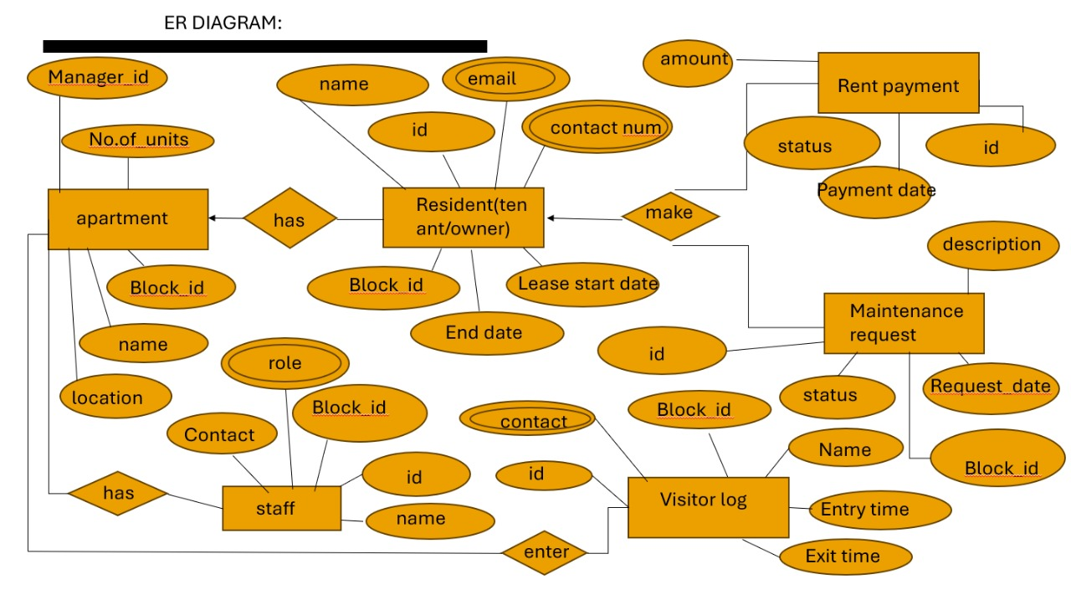

CHAPTER 2

DESIGN OF RELATIONAL SCHEMAS:

Apartment Table (Apartment)
• Attributes: Apartment(Apartment_ID, Name, Location, Number_of_Units, Manager_ID)
• Primary Key: Apartment_ID

Resident Table (Resident)
• Attributes: Resident(Resident_ID, Name, Contact_No, Email, Apartment_ID, Lease_Start_Date, Lease_End_Date)
• Primary Key: Resident_ID
• Foreign Key: Apartment_ID

Staff Table (Staff)
• Attributes: Staff(Staff_ID, Name, Role, Contact_No, Apartment_ID)
• Primary Key: Staff_ID
• Foreign Key: Apartment_ID

Maintenance Request Table (Maintenance_Request)
• Attributes: Maintenance_Request(Request_ID, Resident_ID, Request_Date, Status, Description)
• Primary Key: Request_ID
• Foreign Key: Resident_ID

Rent Payment Table (Rent_Payment)
• Attributes: Rent_Payment(Payment_ID, Resident_ID, Amount, Payment_Date, Status)
• Primary Key: Payment_ID
• Foreign Key: Resident_ID

Visitor Table (Visitor)
• Attributes: Visitor(Visitor_ID, Name, Contact_No, Apartment_ID, Entry_Time, Exit_Time)
• Primary Key: Visitor_ID
• Foreign Key: Apartment_ID

CREATION OF DATABASE TABLES FOR THE PROJECT
CREATE TABLE Apartment (
Apartment_ID INT PRIMARY KEY,
Name VARCHAR(100),
Location VARCHAR(255),
Number_of_Units INT,
Manager_ID INT
);

CREATE TABLE Resident (
Resident_ID INT PRIMARY KEY,
Name VARCHAR(100),
Contact_No VARCHAR(15),
Email VARCHAR(100),
Apartment_ID INT,
Lease_Start_Date DATE,
Lease_End_Date DATE,
FOREIGN KEY (Apartment_ID) REFERENCES Apartment(Apartment_ID)
);

CREATE TABLE Staff (
Staff_ID INT PRIMARY KEY,
Name VARCHAR(100),
Role VARCHAR(50),
Contact_No VARCHAR(15),
Apartment_ID INT,
FOREIGN KEY (Apartment_ID) REFERENCES Apartment(Apartment_ID)
);

CREATE TABLE Maintenance_Request (
Request_ID INT PRIMARY KEY,
Resident_ID INT,
Request_Date DATE,
Status VARCHAR(50),
Description TEXT,
FOREIGN KEY (Resident_ID) REFERENCES Resident(Resident_ID)
);

CREATE TABLE Rent_Payment (
Payment_ID INT PRIMARY KEY,
Resident_ID INT,
Amount DECIMAL(10,2),
Payment_Date DATE,
Status VARCHAR(50),
FOREIGN KEY (Resident_ID) REFERENCES Resident(Resident_ID)
);

CREATE TABLE Visitor (
Visitor_ID INT PRIMARY KEY,
Name VARCHAR(100),
Contact_No VARCHAR(15),
Apartment_ID INT,
Entry_Time DATETIME,
Exit_Time DATETIME,
FOREIGN KEY (Apartment_ID) REFERENCES Apartment(Apartment_ID)
);

-- Inserting data into Apartment table
INSERT INTO Apartment (Apartment_ID, Name, Location, Number_of_Units, Manager_ID)
VALUES
(1, 'Greenwood Apartments', 'Bangalore, India', 50, 101),
(2, 'Silver Oak Residences', 'Chennai, India', 30, 102),
(3, 'Sunrise Heights', 'Mumbai, India', 40, 103),
(4, 'Lakeside View', 'Delhi, India', 20, 104),
(5, 'Mountain Retreat', 'Pune, India', 60, 105);

-- Inserting data into Resident table
INSERT INTO Resident (Resident_ID, Name, Contact_No, Email, Apartment_ID, Lease_Start_Date, Lease_End_Date)
VALUES
(201, 'Rahul Sharma', '9876543210', 'rahul@example.com', 1, '2024-01-01', '2025-01-01'),
(202, 'Priya Kumar', '9123456789', 'priya@example.com', 1, '2023-06-01', '2024-06-01'),
(203, 'Sandeep Rao', '9988776655', 'sandeep@example.com', 2, '2023-07-01', '2024-07-01'),
(204, 'Anita Mehta', '9876543120', 'anita@example.com', 2, '2024-02-01', '2025-02-01'),
(205, 'Vikram Singh', '9445678990', 'vikram@example.com', 3, '2024-03-01', '2025-03-01'),
(206, 'Shivani Patel', '9708975643', 'shivani@example.com', 3, '2024-04-01', '2025-04-01'),
(207, 'Neelam Yadav', '9212346789', 'neelam@example.com', 4, '2023-11-01', '2024-11-01'),
(208, 'Raghav Sharma', '9837465921', 'raghav@example.com', 4, '2023-12-01', '2024-12-01'),
(209, 'Meena Gupta', '9772314530', 'meena@example.com', 5, '2024-05-01', '2025-05-01'),
(210, 'Arvind Soni', '9956438790', 'arvind@example.com', 5, '2024-06-01', '2025-06-01');

-- Inserting data into Staff table
INSERT INTO Staff (Staff_ID, Name, Role, Contact_No, Apartment_ID)
VALUES
(301, 'Anjali Verma', 'Security Guard', '7896541230', 1),
(302, 'Rajesh Kumar', 'Manager', '7896548765', 2),
(303, 'Sita Devi', 'Maintenance Worker', '7891234567', 3),
(304, 'Karan Gupta', 'Accountant', '7895432100', 4),
(305, 'Maya Rani', 'Receptionist', '7898765432', 5);

-- Inserting data into Maintenance_Request table
INSERT INTO Maintenance_Request (Request_ID, Resident_ID, Request_Date, Status, Description)
VALUES
(401, 201, '2024-02-06', 'Pending', 'Water leakage in the kitchen'),
(402, 202, '2024-02-07', 'Completed', 'AC malfunction'),
(403, 203, '2024-03-01', 'In Progress', 'Electrical wiring issues'),
(404, 204, '2024-03-05', 'Pending', 'Plumbing issues'),
(405, 205, '2024-03-10', 'Completed', 'Broken window glass'),
(406, 206, '2024-03-12', 'Pending', 'Elevator malfunction'),
(407, 207, '2024-03-15', 'In Progress', 'Water supply issue'),
(408, 208, '2024-03-18', 'Pending', 'Door lock malfunction'),
(409, 209, '2024-03-20', 'Completed', 'Leaky faucet'),
(410, 210, '2024-03-25', 'Pending', 'Pest infestation');

-- Inserting data into Rent_Payment table
INSERT INTO Rent_Payment (Payment_ID, Resident_ID, Amount, Payment_Date, Status)
VALUES
(501, 201, 15000.00, '2024-02-05', 'Paid'),
(502, 202, 12000.00, '2024-02-10', 'Paid'),
(503, 203, 18000.00, '2024-02-15', 'Pending'),
(504, 204, 16000.00, '2024-02-20', 'Paid'),
(505, 205, 14000.00, '2024-02-25', 'Paid'),
(506, 206, 11000.00, '2024-02-28', 'Pending'),
(507, 207, 13000.00, '2024-03-05', 'Paid'),
(508, 208, 15000.00, '2024-03-10', 'Paid'),
(509, 209, 17000.00, '2024-03-15', 'Pending'),
(510, 210, 16000.00, '2024-03-20', 'Paid');

-- Inserting data into Visitor table
INSERT INTO Visitor (Visitor_ID, Name, Contact_No, Apartment_ID, Entry_Time, Exit_Time)
VALUES
(601, 'Vikram Singh', '9988776655', 1, '2024-02-06 10:00:00', '2024-02-06 12:00:00'),
(602, 'Ravi Kumar', '9345678901', 2, '2024-02-07 14:00:00', '2024-02-07 16:00:00'),
(603, 'Anita Soni', '9543218765', 3, '2024-02-08 12:00:00', '2024-02-08 14:00:00'),
(604, 'Rahul Mehta', '9876543211', 4, '2024-02-09 15:00:00', '2024-02-09 17:00:00'),
(605, 'Sushma Yadav', '9394956274', 5, '2024-02-10 09:00:00', '2024-02-10 11:00:00'),
(606, 'Harish Kumar', '9988775566', 1, '2024-02-11 10:00:00', '2024-02-11 12:00:00'),
(607, 'Pooja Verma', '9888776677', 2, '2024-02-12 11:00:00', '2024-02-12 13:00:00'),
(608, 'Vikas Gupta', '9387448211', 3, '2024-02-13 13:00:00', '2024-02-13 15:00:00'),
(609, 'Neha Rani', '9112233445', 4, '2024-02-14 17:00:00', '2024-02-14 19:00:00'),
(610, 'Sandeep Yadav', '9273645123', 5, '2024-02-15 16:00:00', '2024-02-15 18:00:00');

-- SELECT Queries
SELECT * FROM Apartment;
SELECT * FROM Resident;
SELECT * FROM Staff;
SELECT * FROM Maintenance_Request;
SELECT * FROM Rent_Payment;
SELECT * FROM Visitor;SELECT * FROM Resident WHERE Apartment_ID = 1;
SELECT * FROM Maintenance_Request WHERE Resident_ID = 201;SELECT SUM(Amount) AS Total_Rent FROM Rent_Payme
CHAPTER 3

COMPLEX QUERIES BASED ON THE CONCEPTS OF CONSTRAINTS, SETS, JOINS, VIEWS, TRIGGERS AND CURSORS:

Using Constraints

CREATE TABLE Residents (
ResidentID INT PRIMARY KEY,
Name VARCHAR(100) NOT NULL,
Email VARCHAR(100) UNIQUE,
ApartmentID INT,
Age INT CHECK (Age >= 18),
FOREIGN KEY (ApartmentID) REFERENCES Apartments(ApartmentID)
);

Using Set Operations:

SELECT ResidentID FROM Residents
EXCEPT
SELECT DISTINCT ResidentID FROM Maintenance Requests;

Using Joins:

SELECT A.ApartmentID, A. Block, A. FlatNumber, COUNT(Resident) AS Total Residents
FROM Apartments A
JOIN Residents R ON A.ApartmentID = R.ApartmentID
GROUP BY A.ApartmentID, A.Block, A.FlatNumber
HAVING COUNT(R.ResidentID) > 2;

Triggers:

DELIMITER //
CREATE TRIGGER AutoCloseMaintenance
BEFORE UPDATE ON MaintenanceRequests
FOR EACH ROW
BEGIN
IF NEW.ResolvedDate IS NOT NULL THEN
SET NEW.Status = 'Closed';
END IF;
END;
//
DELIMITER ;
Using Views:

CREATE VIEW OpenMaintenanceRequests AS
SELECT MR.RequestID, R.Name AS ResidentName, A.Block, A.FlatNumber, MR.Description, MR.Status
FROM MaintenanceRequests MR
JOIN Residents R ON MR.ResidentID = R.ResidentID
JOIN Apartments A ON R.ApartmentID = A.ApartmentID
WHERE MR.Status = 'Open';

Using Cursors:

DELIMITER //

CREATE PROCEDURE ApplyRentDiscount()
BEGIN
DECLARE done INT DEFAULT FALSE;
DECLARE resID INT;
DECLARE cur CURSOR FOR
SELECT ResidentID
FROM RentPayments
GROUP BY ResidentID
HAVING COUNT(CASE WHEN PaidOnTime = 1 THEN 1 END) >= 6;

DECLARE CONTINUE HANDLER FOR NOT FOUND SET done = TRUE;

OPEN cur;

read_loop: LOOP
FETCH cur INTO resID;
IF done THEN
LEAVE read_loop;
END IF;

UPDATE Residents
SET RentDiscount = 0.05
WHERE ResidentID = resID;
END LOOP;

CLOSE cur;
END;
//

DELIMITER ;

CHAPTER 4

ANALYZING THE PITFALLS, IDENTIFYING THE DEPENDENCIES, AND APPLYING NORMALIZATIONS:

Analysing the Pitfalls:
The development of an Apartment Management System involves several potential pitfalls that must be addressed for its successful implementation. These include:
- Data Redundancy and Inconsistency:
Storing duplicate information across multiple tables can lead to inconsistencies, making data retrieval slower and error-prone. For example, storing tenant or staff details repeatedly in different tables.
- Violation of Data Integrity:
Without proper constraints and validation, errors such as incorrect apartment numbers or staff roles could compromise the accuracy of the data, impacting decisions and overall system trustworthiness.
- Scalability Issues:
If the database is poorly structured, it might struggle to scale as the number of apartments, residents, maintenance requests, and payments increases, leading to slower queries and potential downtime.
- Complex Queries:
Improper database design could lead to overly complex queries, especially when trying to fetch relationships like residents, payments, maintenance requests, and visitors, which could increase resource consumption and degrade performance.
- Dependency on Manual Operations:
An improperly normalized database might require manual intervention to ensure data consistency, leading to human errors, increased workload, and inefficiencies in maintaining the system.
- Security Concerns:
Storing sensitive data such as resident contact details, payment information, and maintenance requests without proper security measures (e.g., encryption, access controls) could expose the system to unauthorized access or breaches.

Identifying the Dependencies:
Dependencies are the relationships between different attributes in the database. Identifying and analyzing these ensures the integrity, efficiency, and correctness of operations.

Functional Dependency
- Every non-primary attribute must depend on the primary key.
- Example: In the Resident table, Resident_ID determines Name, Email, Lease_Start_Date, Lease_End_Date, and Apartment_ID. This means each resident is uniquely identified by their Resident_ID.
Transitive Dependency
- If attribute A depends on attribute B, and attribute B depends on attribute C, then attribute A indirectly depends on attribute C.
- Example: In the Staff table, Apartment_ID depends on Staff_ID, and Apartment_ID determines Apartment Name. Hence, Staff_ID indirectly determines Apartment Name through Apartment_ID.
Partial Dependency
- In composite primary keys, no non-key attribute should depend only on part of the primary key.
- Example: In the Rent_Payment table, attributes like Amount and Payment_Date should depend on Payment_ID, not just on Resident_ID or Apartment_ID separately.
Referential Dependency
- Ensures that foreign keys maintain relationships between tables.
- Example: Resident_ID in the Maintenance_Request table must reference Resident_ID in the Resident table. Similarly, Apartment_ID in the Staff and Visitor tables should reference the Apartment table’s Apartment_ID.

Applying Normalizations:
Normalization is the process of organizing the database to reduce redundancy and avoid dependency issues, improving efficiency, data integrity, and performance. Here’s how normalization is applied step-by-step in the Apartment Management System:

1st Normal Form (1NF):
- Ensure that each table has atomic (indivisible) values and unique rows.
- Example: In the Resident table, the Contact_No should not contain multiple phone numbers. If a resident has multiple phone numbers, we should store them in a separate table (e.g., Resident_Contact).
2nd Normal Form (2NF):
- Remove partial dependencies by ensuring all attributes depend on the whole primary key.
- Example: In the Staff table, Branch_Name depends only on Branch_ID, which is part of the primary key. To comply with 2NF, we should create a Branch table and store Branch_Name there.
3rd Normal Form (3NF):
- Eliminate transitive dependencies by ensuring attributes depend only on the primary key.
- Example: Manager_Name in the Apartment table indirectly depends on Manager_ID (through Staff). We should move Manager_Name to a separate Staff table to avoid transitive dependency.

Boyce-Codd Normal Form (BCNF):
- Resolve scenarios where a non-primary attribute determines another non-primary attribute.
- Example: If Apartment_Type determines Rent_Amount, we can store this relationship in a Rent_Plan table, separating it from the main Apartment table.
4th Normal Form (4NF):
- Eliminate multi-valued dependencies by ensuring all attributes are independent of each other.
- Example: If a resident has multiple parking spots and contact numbers, we should store these attributes in separate tables (Resident_Parking and Resident_Contact).
5th Normal Form (5NF):
- Break down tables further into smaller tables to eliminate redundancy while maintaining the ability to reconstruct the original data.
- Example: If a resident can request multiple maintenance services, and these services can be associated with multiple apartment units over time, we should use a junction table to handle many-to-many relationships like Resident_Maintenance_Request.

CHAPTER 5

IMPLEMENTATION OF CONCURRENCY CONTROL

1. Lock-Based Protocols
In your system, you can use locks to ensure that no two transactions are modifying the same resource simultaneously. For example, when updating a resident's rent payment or a maintenance request, we want to ensure that one transaction completes before another can modify the same data.

Example:
BEGIN TRANSACTION;

-- Lock the relevant record for updates to avoid conflicts
SELECT * FROM RentPayment WHERE Resident_ID = 1 FOR UPDATE;

-- Perform the update
UPDATE RentPayment SET Amount = Amount + 1000 WHERE Resident_ID = 1;

COMMIT;
Here, the FOR UPDATE lock ensures that no other transaction can modify the RentPayment record for the same Resident_ID while this transaction is in progress.

2. Optimistic Concurrency Control
Optimistic concurrency control assumes that conflicts will be rare and allows transactions to proceed without locks, but validates at commit time to ensure that no conflicting updates have occurred.
In the context of your system, this could mean that you allow multiple transactions to perform updates to RentPayment without locks but check whether the data has been modified by another transaction before committing.

Steps:
Read the initial values of RentPayment.
Perform operations based on those values (e.g., add rent).
When committing, check if the data was modified by another transaction in the meantime.
BEGIN TRANSACTION;

-- Perform read operation
SELECT Amount FROM RentPayment WHERE Resident_ID = 1;

-- Assume some operation was done on Amount here, e.g., increase by 1000

-- Validate no other transaction has modified it
SELECT COUNT(*) FROM RentPayment WHERE Resident_ID = 1 AND Amount = <original_amount>;

-- If count is 0, it means another transaction has modified it; otherwise, commit the changes
UPDATE RentPayment SET Amount = Amount + 1000 WHERE Resident_ID = 1;
COMMIT;

3. Transaction Isolation Levels
Use isolation levels to control the visibility of uncommitted data between transactions. Given your system, you might want to prevent issues like dirty reads or non-repeatable reads.
Common isolation levels:
- Read Uncommitted: Allows dirty reads (not recommended for your system).
- Read Committed: Prevents dirty reads.
- Repeatable Read: Prevents dirty reads and non-repeatable reads.
- Serializable: Ensures full isolation, preventing all concurrency-related issues.

Example:

SET TRANSACTION ISOLATION LEVEL REPEATABLE READ;

BEGIN TRANSACTION;
-- Perform operations, ensuring data consistency for the transaction
UPDATE RentPayment SET Amount = Amount + 1000 WHERE Resident_ID = 1;
COMMIT;

4. Two-Phase Locking (2PL)
Two-Phase Locking ensures that transactions follow a strict protocol for acquiring and releasing locks, which prevents deadlock and guarantees serializability.
- Growing Phase: Acquire all necessary locks.
- Shrinking Phase: Release locks.

Example for RentPayment update:
BEGIN TRANSACTION;

-- Growing phase: Lock required resources
SELECT * FROM RentPayment WHERE Resident_ID = 1 FOR UPDATE;

-- Perform the update
UPDATE RentPayment SET Amount = Amount + 1000 WHERE Resident_ID = 1;

-- Shrinking phase: Commit the changes and release the locks
COMMIT;
5. Triggers for Concurrency Control
Triggers can be used to enforce data integrity rules during concurrent operations. For example, you can prevent negative balances in the RentPayment table when updates occur.

Example:

DELIMITER //
CREATE TRIGGER PreventNegativeBalance
BEFORE UPDATE ON RentPayment
FOR EACH ROW
BEGIN
IF NEW.Amount < 0 THEN
SIGNAL SQLSTATE '45000' SET MESSAGE_TEXT = 'Insufficient funds';
END IF;
END //
DELIMITER ;
This trigger ensures that if any transaction tries to update the RentPayment with an amount less than 0, it will raise an error, thus maintaining data consistency even during concurrent updates.

6. Transaction Logging
To track and manage concurrency in case of failures, you can use a TransactionLog table to record every transaction that modifies critical data. This log will help with recovery and auditing.

For example, after updating RentPayment, log the operation:

INSERT INTO TransactionLog (Operation, TableAffected, Description)
VALUES ('UPDATE', 'RentPayment', 'Updated rent for Resident_ID = 1');

7. Simulate Recovery
You might want to simulate the recovery process after a transaction failure (e.g., if a system crashes mid-transaction). A stored procedure can help reset or complete uncommitted transactions.

DELIMITER //
CREATE PROCEDURE SimulateRecovery()
BEGIN
-- Update incomplete or pending transactions (e.g., mark Visitors with missing exit times)
UPDATE VisitorLog
SET Exit_Time = NOW()
WHERE Exit_Time IS NULL;

INSERT INTO TransactionLog (Operation, TableAffected, Description)
VALUES ('UPDATE', 'VisitorLog', 'Exit time auto-updated during recovery simulation');
END //
DELIMITER ;

CHAPTER 6

CODE FOR THE PROJECT

<!DOCTYPE html>
<html lang="en">
<head>
<meta charset="UTF-8">
<meta name="viewport" content="width=device-width, initial-scale=1.0">
<title>Apartment Management Dashboard</title>
<style>
body {
font-family: Arial, sans-serif;
margin: 0;
background: #f4f4f4;
}
header {
background: #007bff;
color: white;
padding: 1rem;
text-align: center;
}
nav {
background: #333;
display: flex;
justify-content: space-around;
padding: 0.5rem 0;
}
nav a {
color: white;
text-decoration: none;
padding: 0.5rem 1rem;
}
nav a:hover {
background: #575757;
}
section {
padding: 1rem;
}
.card {
background: white;
padding: 1rem;
margin-bottom: 1rem;
box-shadow: 0 0 10px rgba(0,0,0,0.1);
}
table {
width: 100%;
border-collapse: collapse;
margin-top: 1rem;
}
th, td {
border: 1px solid #ddd;
padding: 0.5rem;
text-align: left;
}
th {
background: #007bff;
color: white;
}
input, button {
padding: 0.5rem;
margin-top: 0.5rem;
display: block;
width: 100%;
}
button {
background: #007bff;
color: white;
border: none;
cursor: pointer;
}
button:hover {
background: #0056b3;
}
</style>
</head>
<body>
<header>
<h1>Apartment Management System</h1>
</header>

<nav>
<a href="#apartment">Apartments</a>
<a href="#resident">Residents</a>
<a href="#rent">Rent Payment</a>
<a href="#maintenance">Maintenance</a>
<a href="#visitor">Visitors</a>
</nav>

<section id="apartment" class="card">
<h2>Apartment Details</h2>
<form>
<input type="text" placeholder="Apartment Name">
<input type="text" placeholder="Location">
<input type="number" placeholder="Number of Units">
<input type="number" placeholder="Manager ID">
<button type="submit">Add Apartment</button>
</form>
</section>

<section id="resident" class="card">
<h2>Resident Details</h2>
<form>
<input type="text" placeholder="Resident Name">
<input type="text" placeholder="Contact No">
<input type="email" placeholder="Email">
<input type="number" placeholder="Apartment ID">
<input type="date" placeholder="Lease Start Date">
<input type="date" placeholder="Lease End Date">
<button type="submit">Add Resident</button>
</form>
</section>

<section id="rent" class="card">
<h2>Rent Payment</h2>
<form>
<input type="number" placeholder="Resident ID">
<input type="number" placeholder="Amount">
<input type="date" placeholder="Payment Date">
<select>
<option value="Paid">Paid</option>
<option value="Unpaid">Unpaid</option>
<option value="Overdue">Overdue</option>
</select>
<button type="submit">Add Payment</button>
</form>
</section>

<section id="maintenance" class="card">
<h2>Maintenance Request</h2>
<form>
<input type="number" placeholder="Resident ID">
<input type="date" placeholder="Request Date">
<select>
<option value="Pending">Pending</option>
<option value="In Progress">In Progress</option>
<option value="Completed">Completed</option>
</select>
<input type="text" placeholder="Description">
<button type="submit">Add Request</button>
</form>
</section>

<section id="visitor" class="card">
<h2>Visitor Log</h2>
<form>
<input type="text" placeholder="Visitor Name">
<input type="text" placeholder="Contact No">
<input type="number" placeholder="Apartment ID">
<input type="datetime-local" placeholder="Entry Time">
<input type="datetime-local" placeholder="Exit Time">
<button type="submit">Add Visitor</button>
</form>
</section>

</body>
</html>
BACKEND
from fastapi import FastAPI, Depends
from sqlalchemy.orm import Session
from fastapi.middleware.cors import CORSMiddleware
from . import models, schemas, database

models.Base.metadata.create_all(bind=database.engine)
app = FastAPI()

app.add_middleware(
CORSMiddleware,
allow_origins=["*"],
allow_credentials=True,
allow_methods=["*"],
allow_headers=["*"],
)

def get_db():
db = database.SessionLocal()
try:
yield db
finally:
db.close()

@app.post("/residents/")
def create_resident(resident: schemas.ResidentCreate, db: Session = Depends(get_db)):
db_resident = models.Resident(**resident.dict())
db.add(db_resident)
db.commit()
db.refresh(db_resident)
return db_resident

@app.post("/rent-payments/")
def create_rent_payment(payment: schemas.RentPaymentCreate, db: Session = Depends(get_db)):
db_payment = models.RentPayment(**payment.dict())
db.add(db_payment)
db.commit()
db.refresh(db_payment)
return db_payment

CHAPTER 7

RESULT AND DISCUSSION
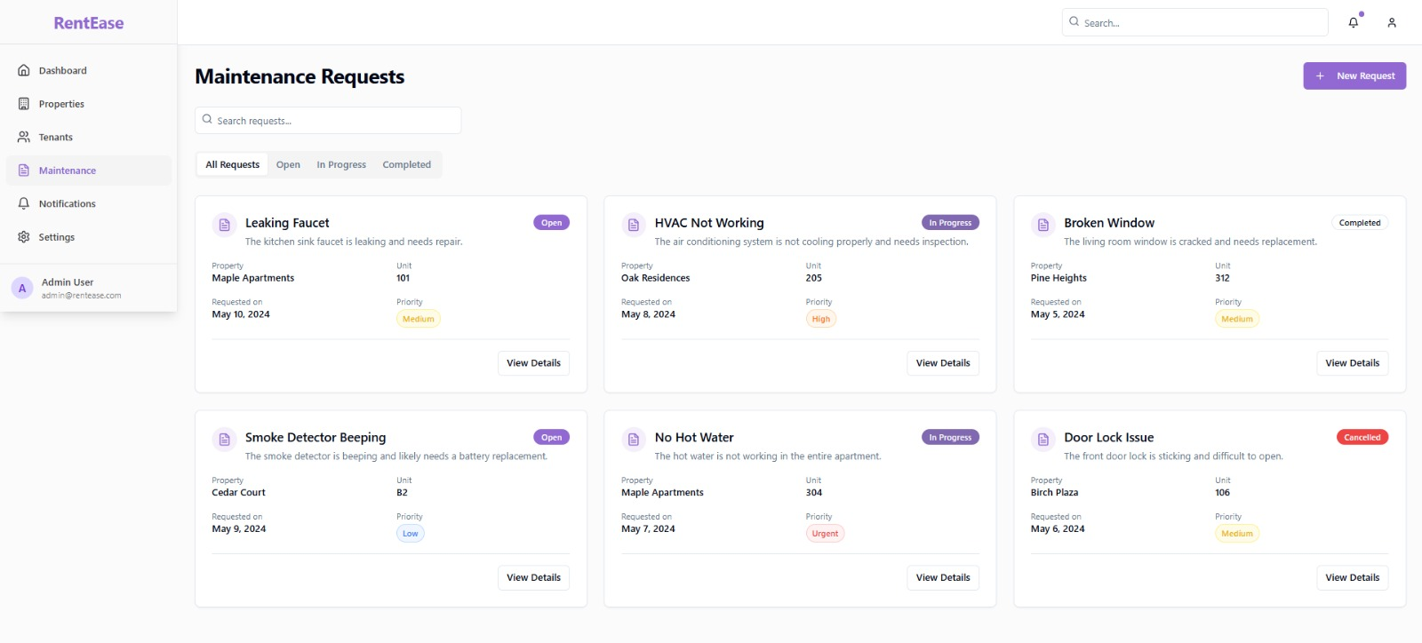

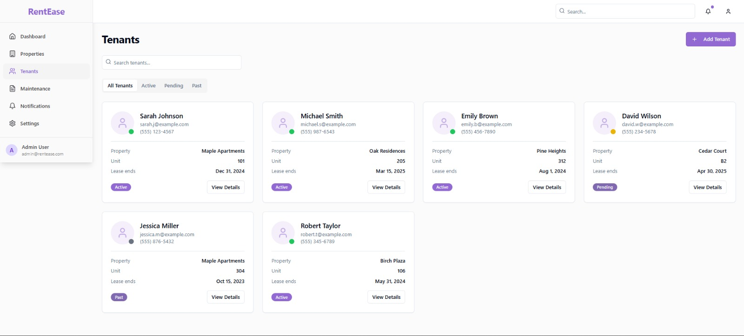

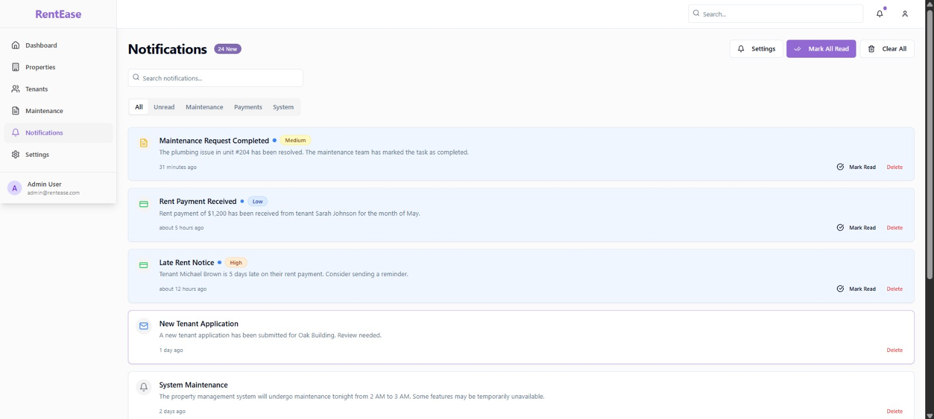

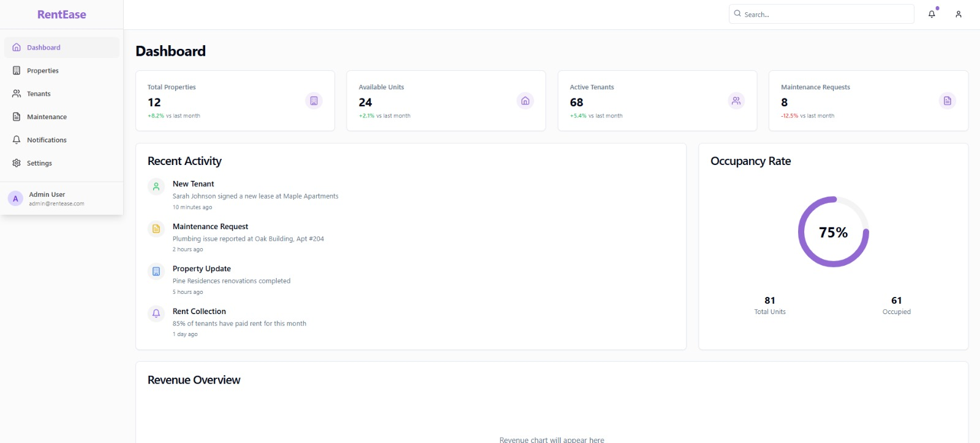

CHAPTER 8

ONLINE COURSE CERTIFICATES:



